**North River Assessment Report**

**ISAT 320**

**Dr. Coffman and Kyle Snow**

**12/07/24**

**Brian La Rosa, Jackson Smith, Kian Soltani, and Danny Diaz**

**Abstract**

This study examined the assessment of the North river watershed emphasizing stream flow, water quality data, benthic macroinvertebrate assessment, and habitat assessment in tributary watersheds over the course of three separate days. Water samples were collected to measure temperature, conductivity, dissolved oxygen, pH, turbidity, and nutrient levels, while water quality and habitat condition measurements, which we performed to evaluate ecological health, varied across different streams for each of the lab groups collecting data. Urban and agricultural areas were linked to poorer water quality and habitat health; whereas, forested covered regions were associated with more robust habitats and better water quality. By studying bottom-dwelling organisms, we gained a deeper understanding of ecosystem health, which aligned with our water quality and habitat data. These findings stress the need for focused watershed management to reduce the negative effects of urban and agricultural runoff and to protect forested areas that support healthy streams.

**Introduction**

The North River is an important tributary that contributes to the Shenandoah River watershed, which has been a vital freshwater source to the Shenandoah Valley for various aspects such as agriculture, industry, and residential needs while supporting diverse ecosystems. We examined part of the North River and also Blacks Run which is a tributary that was assigned to us. Our experiments and evaluations main objective is to evaluate the North River's ecological health and identify any possible problems early on to protect biodiversity. We can get a better understanding of the factors influencing the river's overall health by examining biological indicators, habitat features, and water quality. Aquatic ecosystems rely on clean water, and any degradation in quality can have major consequences, including habitat and biodiversity loss. Measurements that we gathered, such as dissolved oxygen, pH, turbidity, and nutrient levels, can provide valuable information about the health of the river.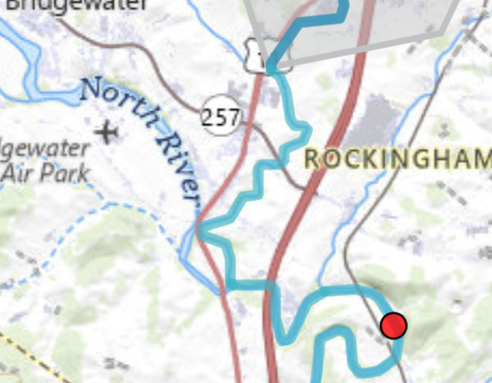

Our evaluation process analyzes some physical factors of the North River such as bank stability, vegetation cover, substrate composition, and flow patterns. These factors have an important impact on the living environment for aquatic species living within the North River. Stable habitats contain well diverse and adaptable ecosystems; however, habitat loss caused by erosion or sedimentation can disrupt ecological processes and negatively impact water quality. Fish and macroinvertebrates can be a great biological indicator of the water quality. Some of the species, such as leeches, thrive in polluted surroundings while others, such as mayflies and caddisflies, can only survive in cleaner water. The quantity and diversity of fish species, such as fallfish and blunt-nosed minnows, can provide valuable insights into the overall health of the ecosystem. This is why we consider monitoring fish and macroinvertebrate populations as an effective tool for assessing water quality.

Using GIS technologies to produce maps that display the North River watershed, tributary sampling locations, and land use patterns, such as urban, agricultural, and forested areas, enhanced our study. These maps aided us in locating sites for habitat assessment and water quality monitoring. The data collected including biological metrics from fish and macroinvertebrates, chemical measurements like pH and dissolved oxygen, and physical characteristics like temperature and turbidity, provides insights into the interactions between human activities and environmental conditions. This information can inform conservation efforts, legislative decisions, and public awareness campaigns. While course textbooks, readings, and lab assignments influence technique and analysis, resources like the Virginia Department of Environmental Quality offer a lot of useful information on water quality standards and regulations. Incorporating these materials gives us a thorough understanding of the North River's environmental health.

**Materials & Methods**

**Intro**

The goal of this lab series was to collect and analyze data on the health and quality of the North River Watershed and our assigned tributary, Blacks Run. First we delineated the North River Watershed and Blacks Run on a map. Then we practiced collecting water quality data (DO, pH, temperature, turbidity, and conductivity) using a Hach meter and various water quality probes on water samples provided to us by our lab instructors.

*Note that all activities involving traversing any part of the watershed were done while wearing a wading suit.

All data collected from the North River was collected at Sandy Bottom Park. Once we arrived at the North River we collected our first water quality data using the water quality probes and determined the health of the habitat. The health of the habitat was measured using a habitat assessment, which determines the health of the habitat based on the quality of various aspects of the environment in and around the river. Two water samples were collected from the river as well. One was collected for E.coli analysis and one was collected for nitrogen, phosphorus, and major anion analysis.

The next time we visited the North River we collected another round of water quality samples using the same probes as before. Then we conducted a benthic macroinvertebrate survey by collecting 200 invertebrates from the river using a seine net and determining how many of each species were collected.

The final time we visited the North River we collected another round of water quality data using the same equipment and methods as the previous two rounds. We also identified and collected samples of fish from each species using an electrofishing unit. Next we manually measured the flow of the river in several spots. We then conducted another habitat assessment.

The last lab period we spent collecting data was at our assigned tributary, Blacks Run. We collected two water samples from our tributary. One was for E.coli analysis and the other was for nitrogen, phosphorus, and major anion analysis. Next we collected a round of water quality data and then we conducted a habitat assessment.

**3.1 Watershed Delineation and Land Use Analysis**

All activities in this section were done on October 2, 2024.

The first part of this project involved practicing delineating watersheds on maps provided to us by our lab instructors. The first 3 practice maps were small sections of watersheds on paper. The last map was of the Harrisonburg area that included the North River Watershed. Once we finished delineating the watersheds on the practice maps, we had the lab assistant, Logan Markell, check our work before requesting the topographical map of the North River Watershed. We delineated the entire watershed including all of its tributaries. We marked the boundary for the portion of the watershed that drained to our sampling location. Then we had one of our lab instructors, Professor Coffman, check our delineation. Once she approved it we copied the delineation over to a paper version of the watershed map. We also identified and delineated our assigned tributary on a separate map that we requested from our lab instructor. Once that delineation was complete we had it checked by Professor Coffman and then copied it onto a paper version.

We then analyzed land use for the areas surrounding the North River Watershed. A figure was provided to us on our lab instruction sheet that provided an array of percentages for each land type for each tributary and for the North River Watershed as a whole. The figure can be found in the lab #6 handout (ISAT 320, 2024a). This figure allowed us to sort the various land types into different categories for each tributary. The main four categories the land types were sorted into were forest, urban, agriculture, and other. Once we sorted the land types into their categories one of us calculated the percentage of each land category for the entire watershed and our assigned tributary. We then discussed what types of land use are most common throughout the watershed and its tributaries. We also discussed how the land use surrounding the watershed and our tributary might affect the water quality.

Finally we practiced collecting water quality data with the Hach meter and the water quality probes. Two water samples were provided to us by our lab instructors for us to use the probes on. We measured the pH, temperature, conductivity, and DO of both samples and recorded them on our datasheet.

Any further details on the delineations, land use analysis, or the practice session for collecting water quality data can be found in the lab #6 handout (ISAT 320, 2024a).

**3.2 Stream Flow**

All activities in this section were done on October 30, 2024.

To measure the flow of the stream we created a representative cross section. To create the cross section one of us grabbed a tape measure, crossed the river, and placed it down on the other side while one of us held the other end of the tape measure at the other side. Once we measured the width of the stream we divided it into ten equal subsections. We established a monitoring point in the middle of each subsection. The monitoring point of each subsection was determined by finding the monitoring point of the first subsection (which we did by adding half a section’s length from the left side of the riverbank) and adding one subsection’s length to that distance for every subsequent section. One of us drew a diagram of the river with our subsections and monitoring points.

We then measured and recorded the depth and velocity at each monitoring point using a stream gauge. The gauge was held above the bottom of the stream by about 4/10ths of the depth to ensure the measurement was accurate. Once all the measurements were conducted one of us calculated the discharge of each subsection and added those discharges together. This entire process was then repeated for a different cross section further downstream.

Any further details on the creation of the cross section or the stream flow measurements can be found in the lab #9 handout (ISAT 320, 2024d).

**3.3 Habitat Assessment**

The activities in this section were done during multiple lab sessions. One was done on October 9, 2024, one on October 30, 2024, and one on November 6, 2024. The ones conducted on October 9 and October 30 were done at Sandy Bottom Park (North River) and the one conducted on November 6 was done at Cecil Wampler Rd (Blacks Run).

We conducted the rapid bioassessment protocol habitat assessment at the North River twice on two separate dates and once at Blacks Run. We conducted the assessment by examining various environmental factors within and surrounding the stream. There were ten total factors to observe and assess. We gave a score between 0 and 20 for each factor (the higher the score the better) and then determined a total score for the entire habitat by adding up the individual scores.

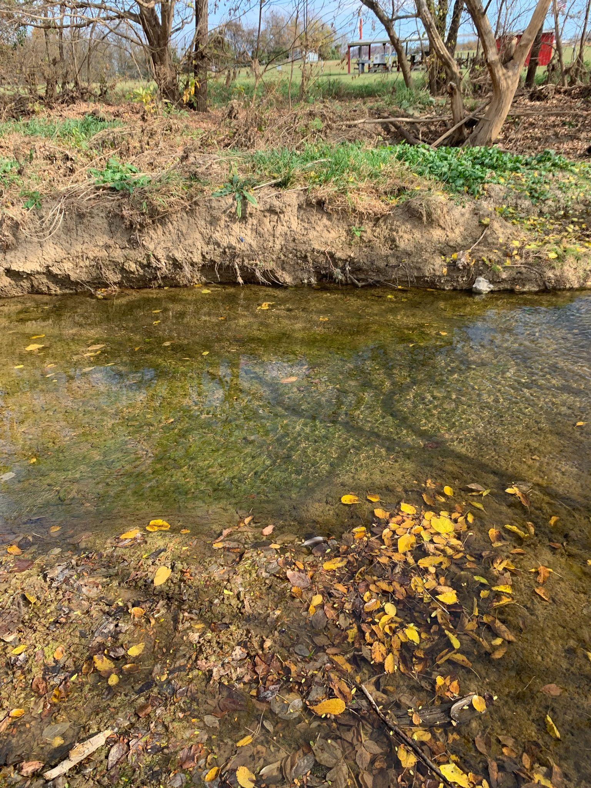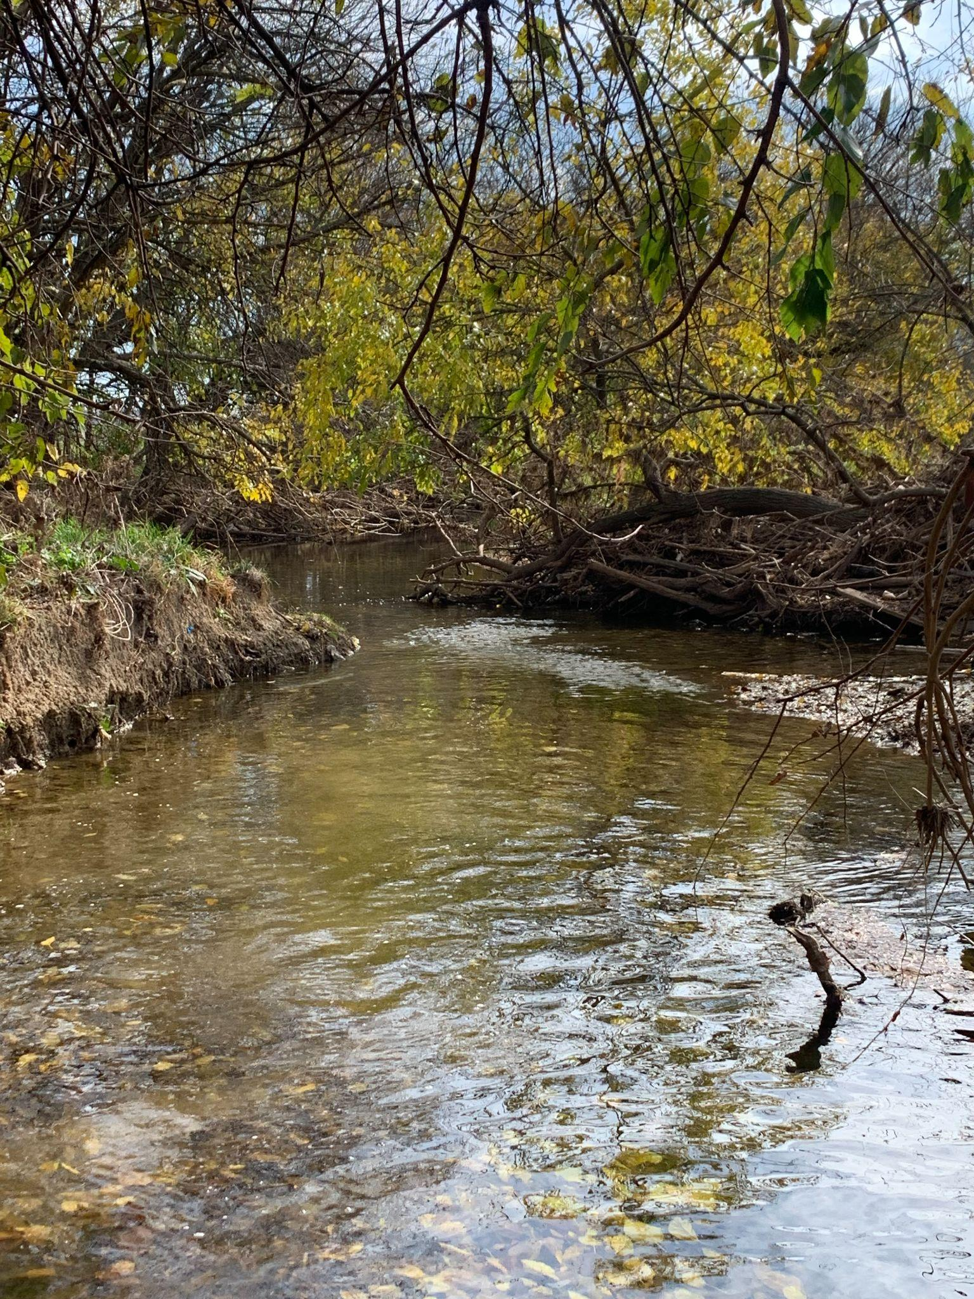

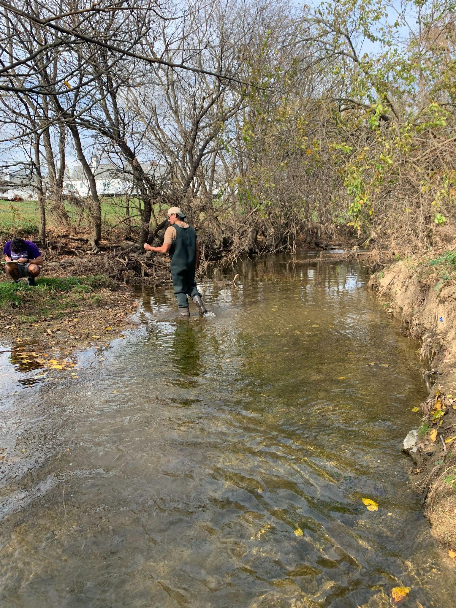

**Figure 1.** Representative Photos for the Blacks Run Habitat Assessment at Cecil Wampler Rd.

Any further details on the habitat assessment can be found in the lab #7 handout (ISAT 320, 2024b), the lab #9 handout (ISAT 320, 2024d), or the lab #10 handout (ISAT 320, 2024e).

**3.4 Water Quality Sampling**

The activities involving the Hach meter and turbidity tube in this section were done during multiple lab sessions. One was done on October 9, 2024, one on October 30, 2024, and one on November 6, 2024. The ones conducted on October 9 and October 30 were done at Sandy Bottom Park (North River) and the one conducted on November 6 was done at Cecil Wampler Rd (Blacks Run). The collection of two water quality samples was done on October 9, 2024 at Sandy Bottom Park (North River) and on November 6, 2024 at Cecil Wampler Rd (Blacks Run).

We collected water quality data at the North River twice on two separate dates and once at Blacks Run. The water quality sampling includes measuring DO, pH, temperature, turbidity, and conductivity readings, as well as collecting two water quality samples from the North River. We collected the turbidity data by filling a turbidity tube to the top with water. One of us then looked down the tube at the secchi disk and another member drained the water from the tube until the person staring down the tube could clearly distinguish between the four quarters of the disk. One of us then recorded the height of the remaining water on the datasheet.

We collected the other readings using the Hach meter and the various water quality probes. One of the three probes was attached to the Hach meter at a time. First we measured pH. One of us removed the cap of the liquid bottle at the tip of the pH probe and then plugged the probe into the Hach meter, making sure to tighten the locking nut. One of us then waded into the river with the Hach meter and the probe. The end of the probe was dipped two to three inches into the water and then the “READ” option was selected. The person in the river then waited for the progress bar to fill up and once it did another person recorded the pH and temperature levels of the water on the datasheet.

The same process was repeated for the other two probes. The only differences were that the other probes didn’t have their tips screwed onto a bottle filled with liquid and the temperature reading was only taken once, not three separate times with each probe.

We collected the two water samples in two plastic bottles with screw-on caps. The 125 mL plastic bottle was used for E.coli analysis and the 500 mL plastic bottle was used for the nitrogen, phosphorus, and major anions analysis. One of us waded into the middle of the river, upstream of any disturbances with the two bottles. The bottles were then rinsed with river water. The person then removed the cap of the first bottle and, facing upstream, submerged the bottle to ⅓ of the depth of the river. The bottle was allowed to fill completely before being capped. That process was then repeated for the second bottle. Both bottles were flipped upside down once they were thought to be full to ensure there were no significant air pockets. Once both bottles had been brought back to the riverbank one of us labeled them with an identifying code as shown below:

* S3G1 - NR1
* S3G1 - NR2

* Note that the samples from Blacks Run were labeled with BR for the location abbreviation.

* Note that the bottle for E.coli analysis from Blacks Run had a volume of 250 mL.

The sample codes were recorded on the chain of custody form and the datasheet. The bottles were stored in a cooler with an ice pack and brought back to the lab.

*Note that a YSI sonde was deployed by the lab instructors, Professor Coffman and Kyle Snow between October 23 and October 30 to gather continuous water quality data. The instrument measures the same parameters that we’d been measuring with the Hach Meter, but it takes readings and records them every 15 minutes. It performed these measurements with this interval for the entire week.

Any further details on the water quality sampling techniques and water quality data collection can be found in the lab #7 handout (ISAT 320, 2024b) and the lab #8 handout (ISAT 320, 2024c).

**3.5 Benthic Macroinvertebrate Assessment**

All activities in this section were done on October 23, 2024.

First our whole group waded to a riffle in the center of the river with a seine net. Part of the net was then submerged to the bottom of the riverbed at a 45 degree angle by one of the group members. Another group member found cobblestones from an area outside of the collection area, washed them off underwater, and placed them at the bottom of the net to anchor it down. One of the group members then waded a bit upstream from the net and shuffled their feet along the riverbed for twenty seconds to dislodge any macroinvertebrates residing on it. For the final five seconds of dislodging the macroinvertebrates the riverbed was scraped with their hands. The anchor stones were then rubbed to remove any organisms that may have attached themselves to them and then they were moved off the net. The seine net was then removed from the stream with a scooping, forward motion. We then made sure no organisms that weren’t macroinvertebrates were trapped in the net and carried it back to the riverbank.

We then placed the net on a plastic sheet and unfolded it. We picked up and identified each macroinvertebrate with a VASOS identification sheet. We also had Professor Coffman helping us with the identification process. Then we placed each macroinvertebrate into sections of ice cube trays that were assorted by species, making sure to tally the number of individuals of each species. Once we found every organism on the surface of the net, we examined the underside of the net and the surface of the plastic sheet. Any additional organisms found were identified, tallied, and placed into their respective sections of the ice cube trays. We repeated the collection and identification procedure once more to reach the minimum of 200 organisms. Once the organisms from the second dip had been tallied, one of us calculated six metrics and compiled them into one index value using the VASOS field calculation sheets.

Any further details on the benthic macroinvertebrate assessment process can be found in the lab #8 handout (ISAT 320, 2024c).

**3.6 Fish Community Survey**

All activities in this section were done on October 30, 2024.

One of our group members participated in the fish collection process. They went upstream with the lab instructor, Kyle Snow. The fish in the stream were stunned with a backpack-mounted electrofishing unit. They were than captured in dip nets and transferred into 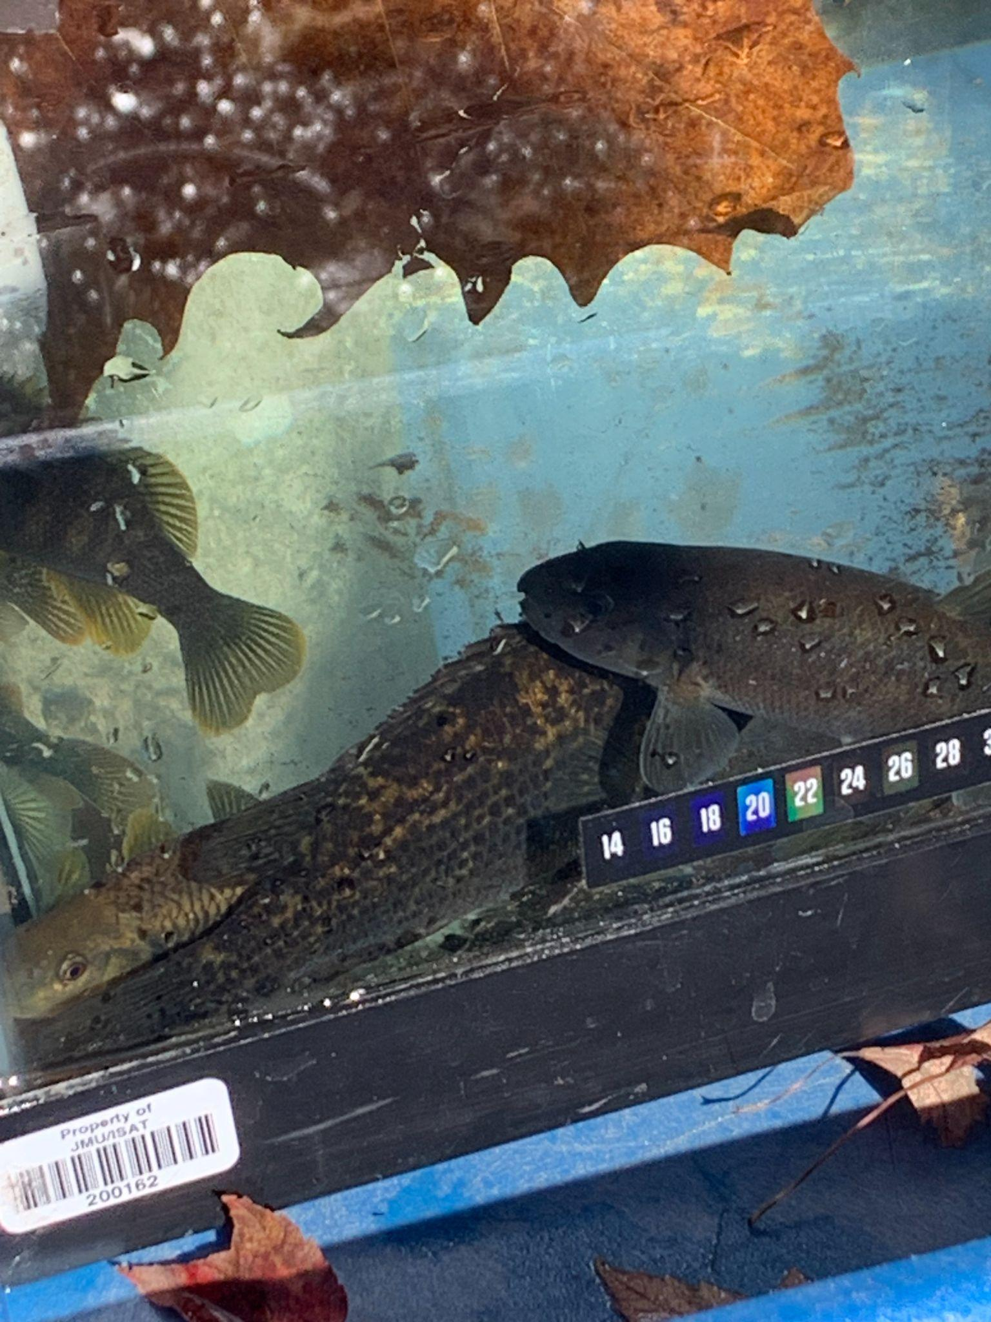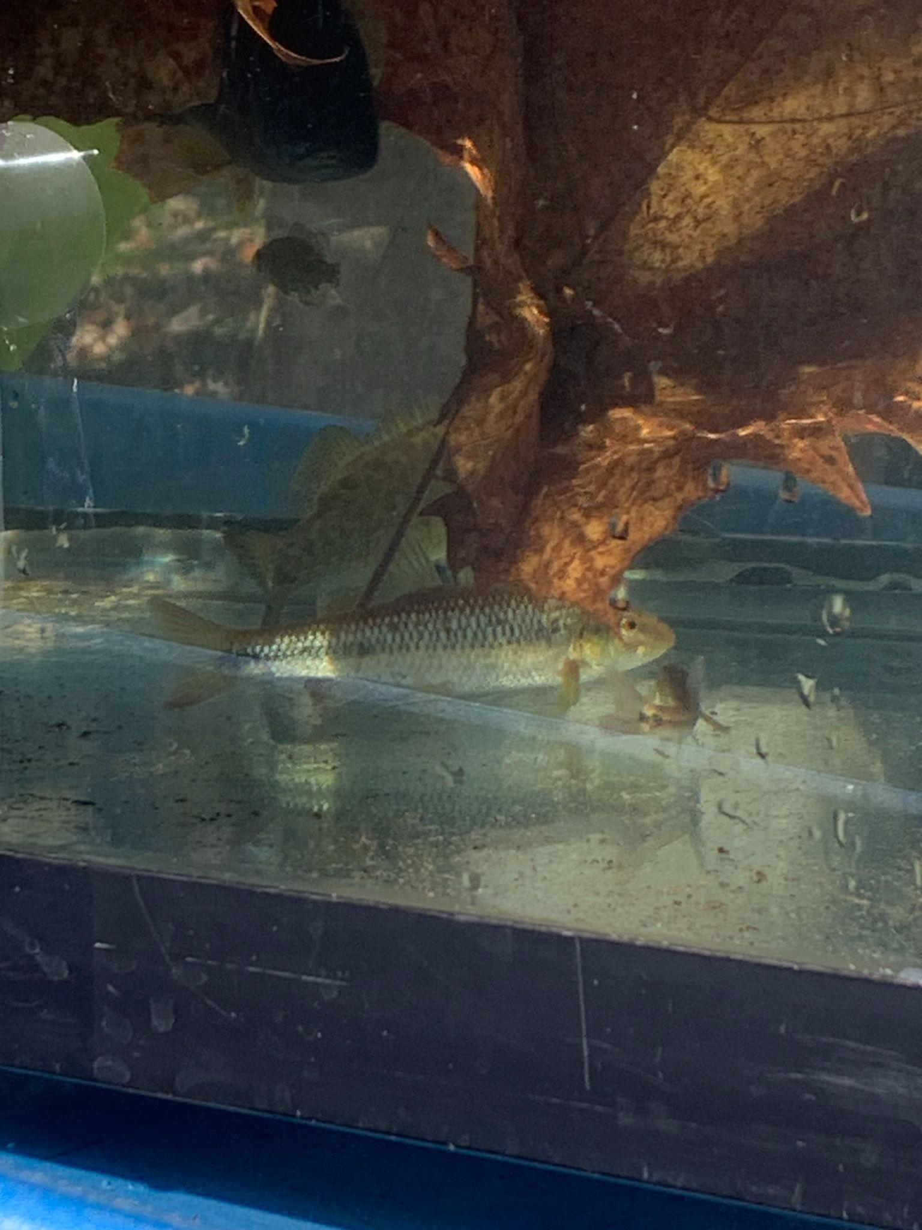buckets. The fish in those buckets were transferred into an aerated tank.

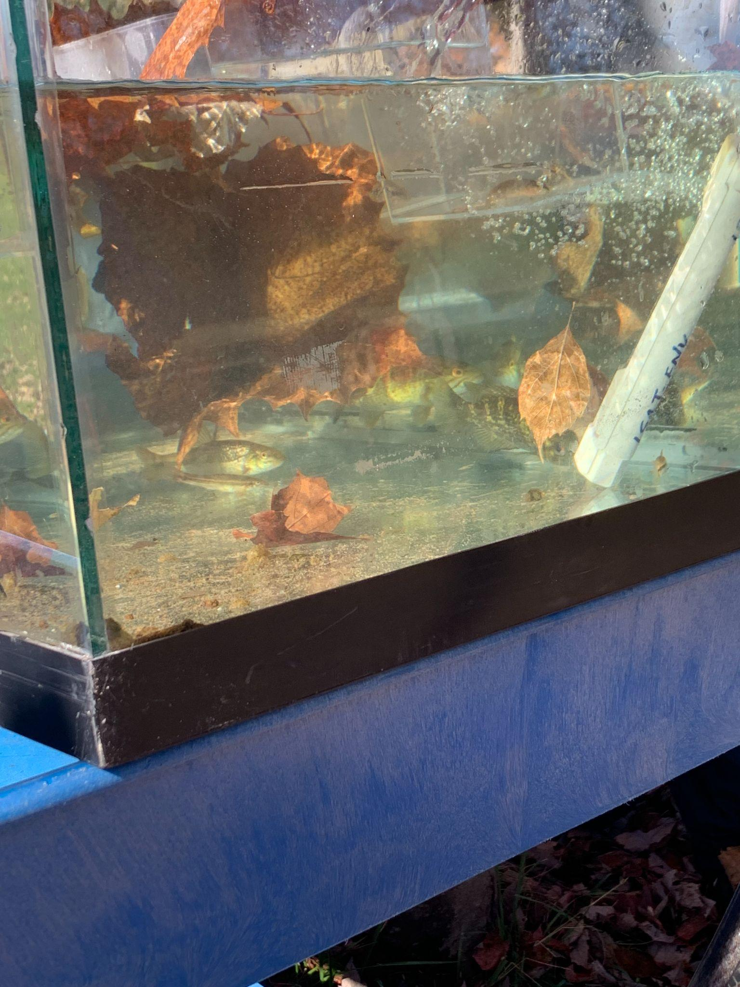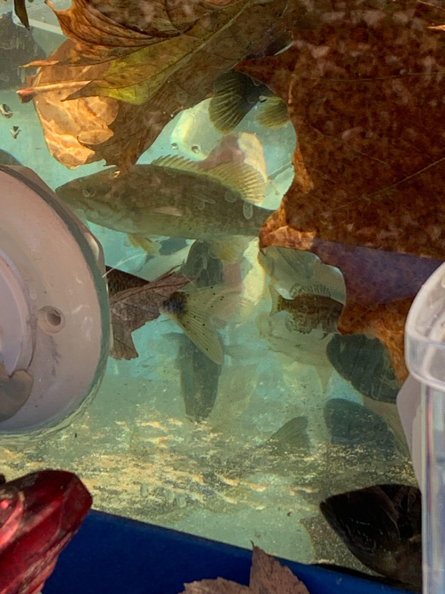

**Figure 2.** Photos of the various fish in an aerated tank collected from the North River at Sandy Bottom Park.

They were then identified using the “Pennsylvania Fishes” poster. Any unidentifiable fish had their physical characteristics recorded. Physical characteristics include body shape, fin arrangement, position and orientation of the mouth, and tail shape. One of us then completed the checklist and tallied the number of families and species we identified. One of us recorded the checklist in our datasheet. Once all groups had identified the fish they were released back into the stream.

Any further details on the fish collection and identification processes can be found in the lab #9 handout (ISAT 320, 2024d).

**4.1 Watershed Delineation and Land Use Analysis**

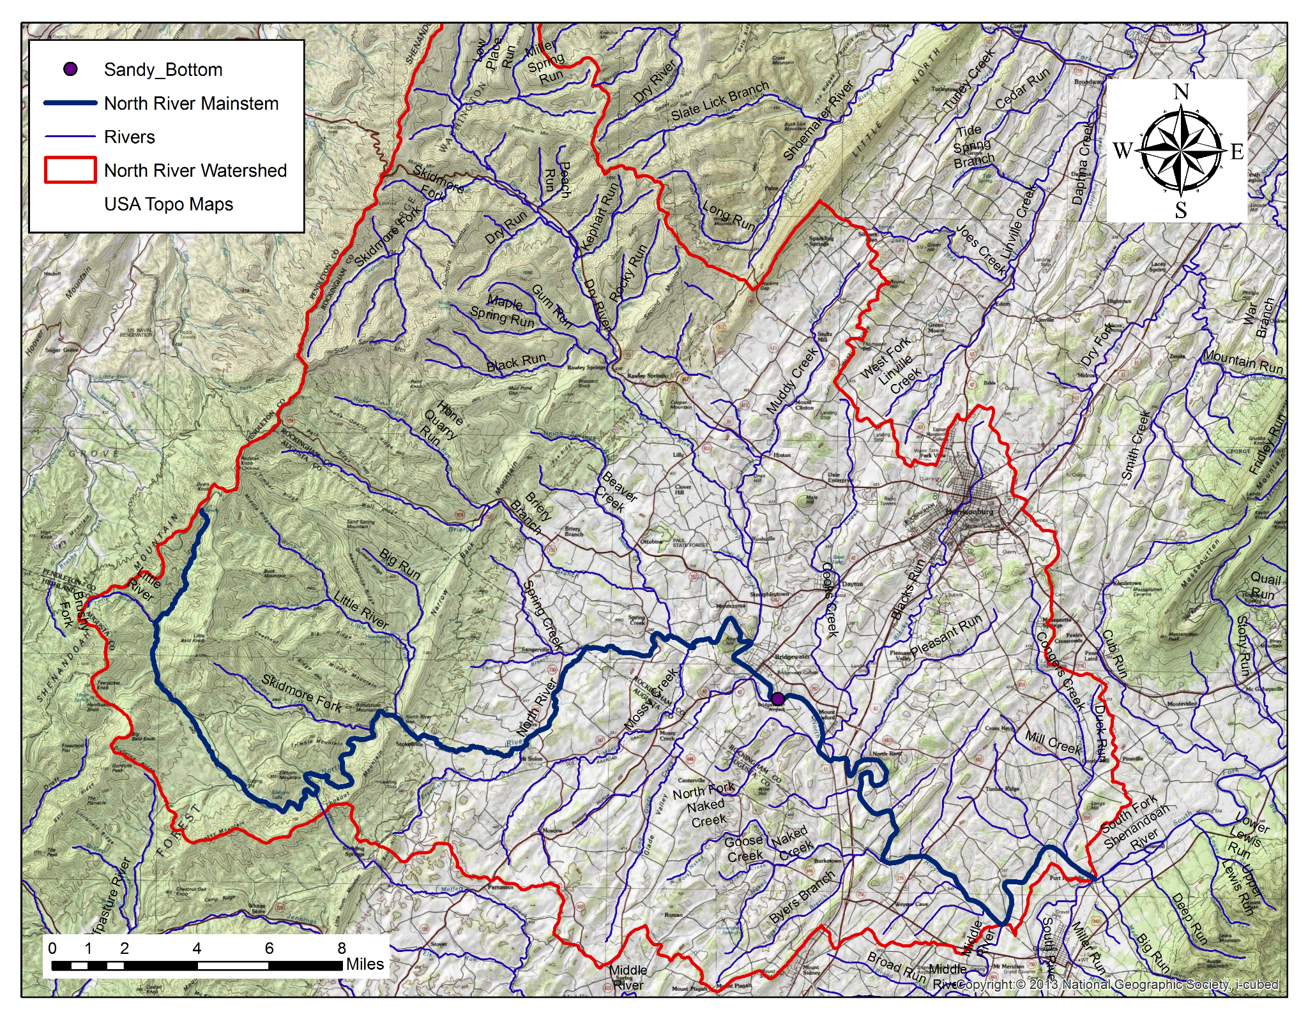

**Figure 3**. Spatial Distribution of Land Use Types within the North River Watershed

**Discussion of Figure 3**

The North River watershed includes a mix of agricultural, urban and forested areas, as shown on the map. These different land uses play a big role in shaping the habitat and water quality within the streams throughout the watershed. Agricultural areas, such as those surrounding Muddy Creek and Cooks Creek, dominate large portions of the watershed and contribute to substantial nutrient and sediment pollution. This pollution of agricultural runoff elevates nitrogen and phosphorus within the watershed leading to eutrophication. Urban streams like Blacks Run are characterized by higher conductivity and altered pH due to urban runoff. In contrast, forested areas like Upper Dry River maintain good water quality, with lower nutrient loads and more stable chemical parameters. The sampling sites downstream of Sandy Bottom reflect the combined impacts of these upstream land use patterns, showing agricultural runoff, urban stormwater, forested buffers and how they interact to affect the general water quality.Soil erosion from these areas increases turbidity, reducing light penetration and degrading habitats for aquatic plants and macroinvertebrates. The land use percentages for key tributaries, including Blacks Run, Cooks Creek, Mossy Creek, Muddy Creek, Pleasant Run, and Upper Dry River, highlight distinct patterns that directly impact water quality and aquatic habitats (Table 1).

**Table 1**. Percent of tributary land use for each tributary.

| **Tributary watershed** | **% Forest** | **% Urban** | **% Agricultural** | **% Other** |
| --- | --- | --- | --- | --- |
| Blacks Run | 9.36 | 64.96 | 25.48 | 0.18 |
| Cooks Creek | 9.28 | 21.48 | 69.06 | 0.16 |
| Mossy Creek | 21.63 | 6.8 | 71.57 | 0.02 |
| Muddy Creek | 37.11 | 7.66 | 54.76 | 0.49 |
| Pleasant Run | 18.25 | 9.48 | 71.87 | 0.4 |
| Upper Dry River | 97.84 | 1.7 | 0.09 | 0.37 |

The table above summarizes the land use percentages for the entire North River watershed and its six focal tributary watersheds. The land uses have been categorized into forest, urban, agricultural, and other, indicating notable variations across the tributaries. Some takeaways from the table itself is that Blacks Run, the watershed that our group analyzed, indicated the highest percentage of urban land use, which is associated with increased conductivity and shifts in pH levels, showing the effects of urban runoff. On the other hand, the region of the Upper Dry River indicated a 97.84% forest land use, which meant that there was minimal pollutants and natural filtration leading to an overall higher water quality (Table 1). The Muddy Creek tributary shows a more balanced watershed with around 54% agricultural land use and 37% forest cover, which means that there is a reduction in the severity of pollutant impacts compared to more heavily farmed tributaries. Meanwhile, tributaries such as Crooks Creek, Mossy Creek, and Pleasant Run show how vital agricultural land use is as illustrated with their percentages all exceeding 69%, which likely reduces the severity of pollutant impacts (Table 1). The tributary watersheds downstream of Sandy Bottom encapsulate the impacts of upstream land uses. Tributaries like Cooks Creek receive runoff from agricultural areas and Blacks Run is impacted by runoff from urban pollution. The runoffs affect the watershed’s E. coli levels, turbidity, and amount of nutrients available in each of the respective watersheds.

**4.2 Stream Flow**

**Table 2.** Discharge rate across all groups

| **Across All Groups** | **Discharge Rate m^3/sec Avg** | **Discharge Rate m^3/sec Max** | **Discharge Rate m^3/sec Min** | **Discharge Rate m^3/sec Range** | **Discharge Rate m^3/sec STDEV** |
| --- | --- | --- | --- | --- | --- |
| All Groups | 3.5 | 8 | 1.7 | 6.3 | 1.7 |

**Table 3.** Discharge rate measured by Burketown Monitoring Site for the approximate hours between 9:00AM and 1:00PM

| **Burketown Monitoring Site** | **Discharge Rate m^3/sec Avg** | **Discharge Rate m^3/sec Max** | **Discharge Rate m^3/sec Min** | **Discharge Rate m^3/sec Range** | **Discharge Rate m^3/sec STDEV** |
| --- | --- | --- | --- | --- | --- |
| All Groups | 4.7 | 4.7 | 4.6 | 0.1 | 0.04 |

The Burketown Monitoring Site had very consistent data throughout the measured period, whereas our class data was much more varied. This discrepancy was likely due to system and human errors. One issue was that we measured the stream flow area as if it were a rectangle, even though it was not a perfect rectangle. Additionally, several groups participated, and one group even recorded a discharge rate of 8, indicating that they must have made an error. Despite the outlier of 8, our class's streamflow measurements were still lower overall, highlighting that our recordings were neither very reliable nor consistent.

**4.3 Habitat Assessment**

**Table 4.** Summary statistics of all groups for habitat score for Sandy Bottom.

| **Location** | **Lab Group** | **Habitat Score** | **avg** | **Min** | **Max** | **Range** | **Stdev** |
| --- | --- | --- | --- | --- | --- | --- | --- |
| Sandy Bottom | S1G1 | 127 |  |  |  |  |  |
|  | S1G2 | 125 |  |  |  |  |  |
|  | S1G3 | 129 |  |  |  |  |  |
|  | S1G4 | 134 |  |  |  |  |  |
|  | S1G5 | 115 |  |  |  |  |  |
|  | S3G1 | 137 |  |  |  |  |  |
|  | S3G2 | 140 |  |  |  |  |  |
|  | S3G3 | 137 |  |  |  |  |  |
|  | S3G4 | 157 |  |  |  |  |  |
|  | S3G5 | 140 |  |  |  |  |  |
|  | S3G6 | 141 |  |  |  |  |  |
|  | **Summary Statistics** |  | **134.73** | **115** | **157** | **42** | **10.85** |

The table above explains the summary statistics for all 11 of the groups. The statistics incorporated in Table 4 are the minimum, maximum, range, average, and standard deviation (STDEV) for the habitat assessment scores. One of the key takeaways is the noticeable difference in scores between the first section and the second section. For instance, group five from section one recorded a habitat assessment score of 115, whereas the second section assigned a significantly higher score of 140. The overall range of habitat scores was a substantial 42 (Table 4). This inconsistency is unlikely to reflect actual environmental changes, as both sections conducted their assessments on the same day. Rather, this inconsistency could be linked to external factors. A possible explanation could be that there was a lack of adequate sunlight when the first section was performing their habitat assessment scores, which may have obscured key habitat features, such as the riparian corridor. Another contributing factor could be down to human error as students in the first section might have been less alert and thorough in their observations due to early morning fatigue.

**Table 5.** Summary Statistics of habitat score for each tributary

| **Tributary** | **Lab Group** | **Habitat Score** | **avg** | **Min** | **Max** | **Range** | **Stdev** |
| --- | --- | --- | --- | --- | --- | --- | --- |
| Blacks Run | S1G1 | 75 |  |  |  |  |  |
|  | S3G1 | 128 |  |  |  |  |  |
|  | Summary Statistics |  | 102 | 75 | 128 | 53 | 37.477 |
| Cooks Creek | S1G2 | 128 |  |  |  |  |  |
|  | S3G2 | 109 |  |  |  |  |  |
|  | Summary Statistics |  | 119 | 109 | 128 | 19 | 13.435 |
| Mossy Creek | S1G3 | 121 |  |  |  |  |  |
|  | S3G3 | 113 |  |  |  |  |  |
|  | Summary Statistics |  | 117 | 113 | 121 | 8 | 5.6569 |
| Muddy Creek | S1G4 | 89 |  |  |  |  |  |
|  | S3G4 | 128 |  |  |  |  |  |
|  | Summary Statistics |  | 109 | 89 | 128 | 39 | 27.577 |
| Pleasant Run | S1G5 | 122 |  |  |  |  |  |
|  | S3G5 | 106 |  |  |  |  |  |
|  | Summary Statistics |  | 114 | 106 | 122 | 16 | 11.314 |
| Upper Dry River | S3G6 | 130 |  |  |  |  |  |

In addition to our findings at Sandy Bottom, Table 5 outlines the habitat assessment scores for each tributary and their notable variations. Our lab group’s habitat that we had to assess, Black’s Run, exhibited the widest range in habitat scores, with values ranging from 75 to 128, resulting in a standard deviation of 37.48. This substantial variability may be a result of urban runoff due to the urban land use near the watershed, which likely affects habitat conditions. In contrast, a more balanced region like the Mossy creek that contains both forested and agricultural regions had the lowest range between habitat scores. The solely agricultural regions, however, like those surrounding Muddy Creek, Cooks Creek, & Pleasant Run showed moderate variability in scores and are likely influenced by nutrient and sediment pollution from agricultural runoff. The Upper Dry River region, with its forested surroundings, recorded the highest habitat score of 130, showing how forested landscapes can help mitigate pollution and support healthier aquatic ecosystems. Overall, the habitat assessment scores reflect how land use impacts habitat quality with agricultural and urban runoff contributing to lower scores; while in contrast, forested covered regions support watershed stability.

**4.4 Water Quality Sampling**

**Table 6.** October 9th water quality readings.

| Day 1  (Lab 7) | Temperature Celcius | Conductivity (uS/cm) | Dissolved Oxygen (mg/L) | pH | Turbidity (NTU) |
| --- | --- | --- | --- | --- | --- |
| avg | 14.8 | 181.7 | 9.7 | 7.9 | <5 |
| Max | 16.3 | 196.7 | 9.9 | 8.1 | <5 |
| Min | 13.7 | 95 | 9.5 | 7.8 | <5 |
| Range | 2.6 | 101.7 | 0.3 | 0.3 | <5 |
| Stdev | 0.8 | 31.6 | 0.1 | 0.1 | <5 |

**Table 7.** October 23rd water quality readings.

| Day 2  (Lab 8) | Temperature C | Conductivity (uS/cm) | Dissolved Oxygen (mg/L) | pH | Turbidity (NTU) |
| --- | --- | --- | --- | --- | --- |
| avg | 14 | 331.5 | 10.1 | 8.3 | <5 |
| Max | 16 | 339 | 10.6 | 8.4 | <5 |
| Min | 12.5 | 323 | 9.8 | 8.2 | <5 |
| Range | 3.5 | 16 | 0.8 | 0.2 | <5 |
| Stdev | 1.4 | 4.9 | 0.3 | 0.1 | <5 |

**Table 8.** October 30th water quality readings.

| Day 3  (Lab 9) | Temperature Celcius | Conductivity (uS/cm) | Dissolved Oxygen (mg/L) | pH | Turbidity (NTU) |
| --- | --- | --- | --- | --- | --- |
| avg | 13.2 | 353.7 | 10.1 | 8.4 | <5 |
| Max | 14.1 | 396 | 10.8 | 8.7 | <5 |
| Min | 12.1 | 340 | 9.5 | 8.2 | <5 |
| Range | 2 | 56 | 1.4 | 0.6 | <5 |
| Stdev | 0.8 | 19.5 | 0.5 | 0.2 | <5 |

The water quality readings and statistics collected across the three days spent at the North River tributary showed some similarities in turbidity scores, but primarily clear dissimilarities in temperature, conductivity, dissolved oxygen, and pH. The water temperature remained consistent across the sampling days, with averages ranging from 13.2°C on Day 3 to 14.8°C on Day 1, which are all below the 31°C limit set for aquatic ecosystems (Table 6). The gradual cooling trend observed throughout the days aligns with seasonal temperature drops, influencing other water quality parameters. Meanwhile, the conductivity experienced lots of variations beginning on Day 1 with an average of 181.7 rising all the way up to an average score of 353.7 uS/cm on Day 3 (Table 8). The recent spike in conductivity could be related to seasonal changes. When there are higher groundwater levels, this can add minerals to the water, which can boost its conductivity. Although they fluctuated, the dissolved oxygen levels were consistently high throughout our sampling period, ranging from a healthy 9.5 to 10.8 milligrams per liter, which meant that all data samples were above the 5 milligrams per liter minimum. This suggests that the water at Sandy Bottom was a well-oxygenated system. Dissolved oxygen levels can oscillate throughout the day, and our earlier sampling times might have captured the peak morning oxygenation. The average of the pH values were consistently within the acceptable threshold of 6-9 with scores of 7.9 on Day 1, 8.3 on Day 2, and 8.4 on Day 3, which implies that there was effective buffering in the watershed (Table 7). The turbidity level scores were consistently under 5 NTU suggesting that the water has low levels of suspended particles and sediment. For the most part, these parameters were within the acceptable range of water quality standards.

**Table 9.** North River Day 1 is October 9th, North River Day 2 is October 23rd, and North River Day 3 is October 30th. These are summary statistics of the chemical data that was measured.

| **Sample ID** | **Total coliform MPN (cfu/100ml)** | ***E. coli MPN (cfu/100ml)*** | **Total Nitrogen (mg/L - N)** | **Total Phosphorus (mg/L - P)** | **IC - Chloride**  **(mg/L)** | **IC - Nitrate**  **(mg/L)** | **IC - Sulfate**  **(mg/L)** |
| --- | --- | --- | --- | --- | --- | --- | --- |
| North River Day 1 | 6488 | 145 | 2.8 | 0.03 | 5.1 | 11.4 | 7.6 |
| North River Day 2 | >24196 | 116 | 4.1 | 0 | 8.3 | 17.7 | 10.5 |
| North River Day 3 | >24196 | 52 | 4 | 0.01 | 8.7 | 18 | 10.7 |

The water quality results revealed significant trends and variations influenced by land usage and potential runoff impacts. The microbial contamination presented a significant concern. For instance, E. coli levels consistently exceeded the freshwater standard (<126 cfu/100ml). Day 1 recorded relatively lower contamination of 145 cfu/100ml, while Days 2 and Day 3 showed dramatic spikes of over 24196 MPN/100ml (Table 9). The reason for this sudden spike may have been down to runoff from urban or agricultural sources, which could’ve been made worse by an increase in either precipitation or land usage. When comparing water quality across the three sampling days, the first day measured the lowest nutrient levels, implying minimal runoff impacts early in the season. In contrast, the ensuing days depicted more nitrogen and microbial contamination, which points to the effects of runoff and seasonal changes. Differences between morning and evening samples display the impact of daily cycles, especially on temperature and dissolved oxygen. The high levels of nutrients like nitrogen and E. coli show that there needs to be more drastic measures to keep the water quality of a watershed like the North River healthy. A way of doing this could be by implementing strategies like creating buffer zones and improving land use practices to reduce nutrient and bacterial pollution and to protect water quality and aquatic life.

**Table 10.** Results of each group's tributary measurements.

| **Group** | **Location** | **Habitat Assessment Score** | **Temperature (C)** | **Conductivity (uS/cm)** | **Dissolved Oxygen (mg/L)** | **pH** |
| --- | --- | --- | --- | --- | --- | --- |
| S1G1 | Blacks Run | 75 | 16.2 | 626 | 8.5 | 8 |
| S3G1 | Blacks Run | 128 | 18.5 | 623 | 11.5 | 8.2 |
| S1G2 | Cooks Creek | 128 | 17.9 | 602 | 11.5 | 8.2 |
| S3G2 | Cooks Creek | 109 | 17.9 | 602 | 11.5 | 8.2 |
| S1G3 | Mossy Creek | 121 | 16 | 361 | 10.1 | 7.9 |
| S3G3 | Mossy Creek | 113 | 16 | 360 | 10.1 | 7.9 |
| S1G4 | Muddy Creek | 89 | 18.7 | 551 | 11 | 8.2 |
| S3G4 | Muddy Creek | 128 | 17.3 | 582 | 10.6 | 8.2 |
| S1G5 | Pleasant Run | 122 | 18.6 | 637 | 11.4 | 8.2 |
| S3G5 | Pleasant Run | 106 | 16.4 | 648 | 9.5 | 8 |
| S3G6 | Upper Dry River | 130 | 14.8 | 27 | 9.4 | 7 |

Each tributary’s habitat assessment score had some degree of variation between sections, with Blacks Run and Muddy Creek having the greatest disparities. The discrepancy between the Blacks Run score for S1G1 and S3G1 was most likely due to human error on our group’s part. We most likely overestimated certain qualities of our environment when we travelled to our site. The other section’s assessment score is more accurate because the nitrogen, phosphorus, and major anion analysis indicate significant pollution, especially of phosphorus in our tributary (Table 11). This amount of pollution wouldn’t be indicative of a healthy aquatic environment that’s almost on par with the Upper Dry River tributary.

**Table 11.** Results of each group’s nitrogen, phosphorus, and major anion samples.

| **Group** | **Location** | **Total coliform MPN (cfu/100ml)** | ***E. coli MPN (cfu/100ml)*** | **Total Nitrogen (mg/L - N)** | **Total Phosphorus (mg/L - P)** | **IC - Chloride**  **(mg/L)** | **IC - Nitrate**  **(mg/L)** | **IC - Sulfate**  **(mg/L)** |
| --- | --- | --- | --- | --- | --- | --- | --- | --- |
| S1G1 | Blacks Run | 1165 | 15 | 1 | 0.73 | 51.2 | 5 | 26.2 |
| S1G2 | Cooks Creek | 4884 | 142 | 6.7 | 0.01 | 26.3 | 27.1 | 22.1 |
| S1G3 | Mossy Creek | 4884 | 816 | 2.6 | 0.01 | 3.7 | 11.1 | 5 |
| S1G4 | Muddy Creek | 7701 | 480 | 8.7 | 0.14 | 34.2 | 36.5 | 55.9 |
| S1G5 | Pleasant Run | 9450 | 169 | 7.3 | 0.04 | 21.9 | 30.2 | 19.3 |
| S3G6 | Upper Dry River | 461.1 | <1 | 0.1 | 0 | 1.4 | 1 | 3.6 |

None of the tributaries are extremely similar to one another in terms of coliform levels or nitrogen, phosphorus, and major anion levels. Pleasant Run had the highest levels of coliforms, most likely due to fecal matter from fertilizers running off into the water from the surrounding agricultural land, which makes up 71.87 % of the surrounding land (Table 1). Mossy Creek contained the highest level of E.coli, however. Muddy Creek had an extremely high amount of total nitrogen compared to the rest of the tributaries. Blacks Run contained a very high level of phosphorus and chloride, most likely due to industrial runoff from the surrounding urban areas. Muddy Creek contained the highest levels of nitrate and sulfate, which most likely stems from agricultural runoff. Muddy Creek has a higher amount of nitrate, sulfate, and total nitrogen pollution than Pleasant Run and Mossy Creek. This is odd because Pleasant Run and Mossy Creek have significantly more surrounding agricultural land than Muddy Creek does with Pleasant Run being at 71.87 % and Mossy Creek being at 71.57 % (Table 11). A plausible explanation for this is that the farmers near Muddy Creek use fertilizers and pesticides with higher nitrogen and sulfur content levels than the other two tributaries do. It's also possible that the farmers near Muddy Creek are less responsible when it comes to controlling their runoff.

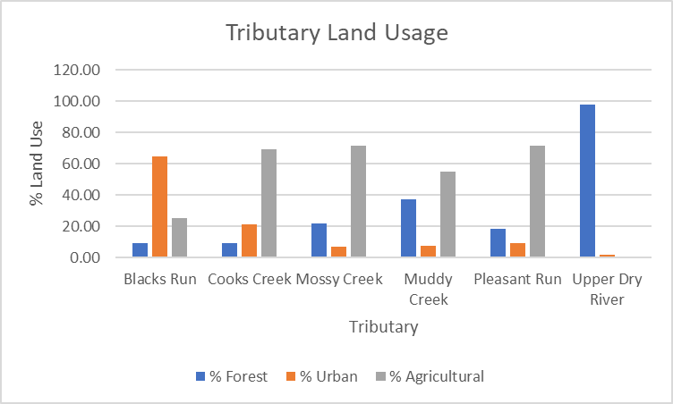

**Figure 4.** Land Usage Percentages for all tributaries

Most of the tributaries had a majority agricultural surrounding land use, with Upper Dry River being mostly surrounded by forest and Blacks Run being mostly surrounded by urban areas. The Upper Dry River being surrounded by mostly natural land led to it getting the highest habitat assessment rating, with a score of 130 (Table 10), as well as an overall higher water quality than the other tributaries (Table 11). Our group’s tributary, Blacks Run, was surrounded by mostly urban areas which led to significant pollution. This pollution led to significantly increased phosphorus levels, a key contributor to eutrophication (Singer, 2016). The other four tributaries had a significant amount of surrounding agricultural land which led to higher nitrogen content (Figure 4) since nitrogen is a commonly found molecule in agricultural products like fertilizer and pesticide.

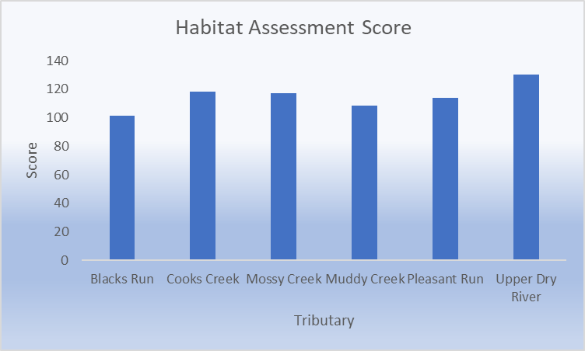

**Figure 5.** Averaged Habitat Assessment Score for each tributary

According to Figure 5, Blacks Run and Muddy Creek had the lowest habitat assessment scores. This is closely tied to land use in these areas. Blacks Run is heavily urbanized, with an industrial factory near the sampling site, contributing to its low score. Muddy Creek and Pleasant Run, which also scored low, are predominantly influenced by agricultural land use. Agriculture often introduces pollutants and other factors that negatively impact habitat quality. In contrast, Cooks Creek and Mossy Creek scored slightly higher, around 120, though they remain influenced by agricultural practices. Upper Dry River had the highest assessment score, likely because it is a headwater stream with minimal exposure to external pollutants.

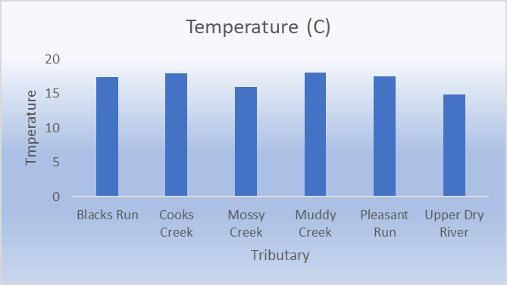

**Figure 6.** Averaged measured temperature for each tributary

The measured temperatures show two discrepancies: Upper Dry River and Mossy Creek were recorded as slightly colder than the other tributaries. This can be explained by the characteristics of the Upper Dry River as a headwater stream, which is typically cooler due to higher elevation and reduced exposure to direct sunlight.

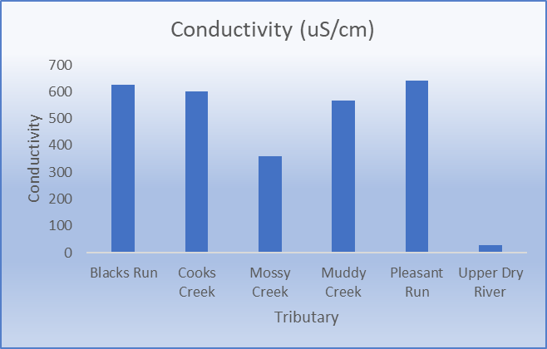

**Figure 7.** Averaged measured conductivity for each tributary

According to Figure 7, the two tributaries that have low conductivity are Mossy Creek and Upper Dry River. This is most likely explained by a lack of mineral content that stimulates an electrical current. The lack of minerals for the Upper Dry River makes sense due to it being a source for downstream tributaries. As runoff is collected throughout the tributaries, Blacks Run, Cooks Creek, Muddy Creek, and Pleasant Run all accumulate more minerals than Mossy Creek and Upper Dry River. A correlation between land usage and conductivity is apparent. Cooks Creek, Muddy Creek, and Pleasant Run are all majority agricultural land usage, meaning that agricultural runoff is most likely the reason for the high conductivity in these tributaries. Mossy Creek is also majority agricultural, but less so than the other three. Blacks run has a high conductivity due to its proximity to urban development likely due to runoff.

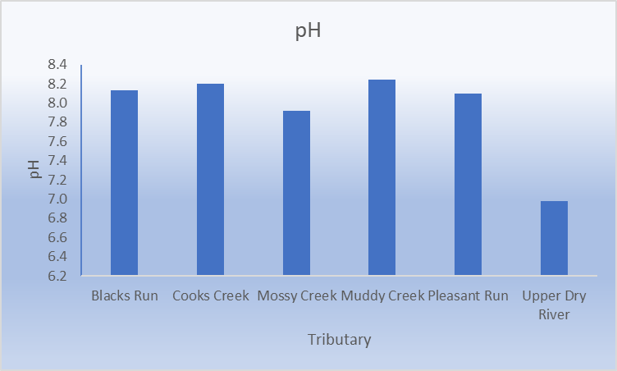

**Figure 8.** Averaged measured pH for each tributary

The main outlier in Figure 8 is the Upper Dry River, likely due to its status as a headwater. Headwaters often have lower pH values because they contain less mineral content, making the water more reactive to environmental inputs. Factors such as rainwater, steep slopes, and small stream size contribute to more acidic conditions. In contrast, the other tributaries exhibit more basic pH levels, likely due to their higher buffering capacity, which resists changes in pH from external influences.

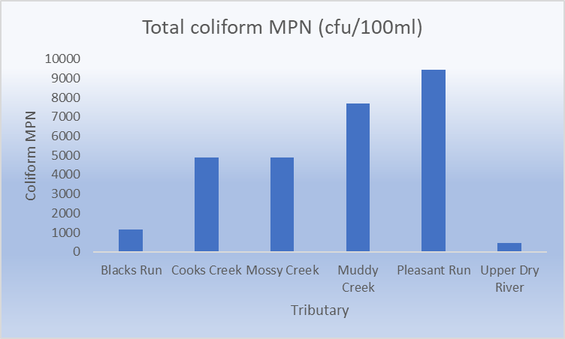

**Figure 9.** Measured Total Coliform MPN for each Tributary

Coliform levels are notably high in Pleasant Run and Muddy Creek, with Mossy Creek and Cooks Creek also showing elevated levels, though not as extreme. This can be attributed to the extensive agricultural land use around these tributaries. Manure, commonly used in agriculture, contains high levels of coliform bacteria, which likely entered the water through runoff. In contrast, Blacks Run exhibited low coliform levels, likely due to its urban runoff, which can be less potent in coliform bacteria.

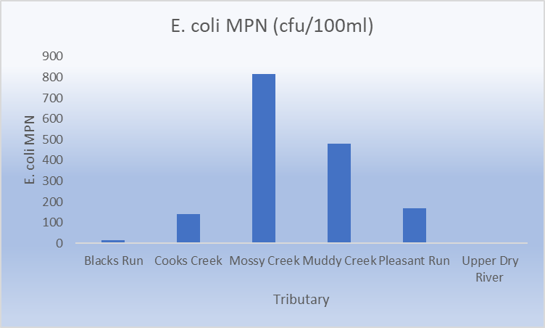

**Figure 10.** Measured E. Coli MPN for each tributary

E. coli, a type of coliform bacteria typically originating from mammalian fecal matter, was found in high levels in Pleasant Run, Muddy Creek, Mossy Creek, and Cooks Creek. All four tributaries exceeded the maximum acceptable level for health 126 (cfu/100ml) (ISAT 320 Dr. Coffman and Kyle Snow, 2024(e)), with Mossy Creek having the highest concentration at approximately 800 cfu/100ml. This significant contamination could result from animals entering the water directly and introducing feces or from runoff carrying manure from surrounding agricultural land.

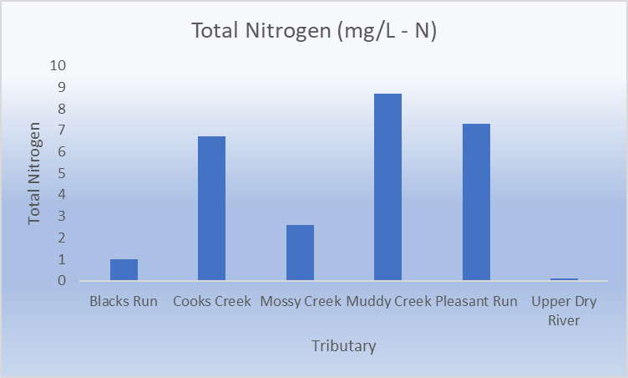

**Figure 11.** Measured total nitrogen present in each tributary

The acceptable range for Total Nitrogen (TN) in water is 2–6 mg/L-N(ISAT 320 Dr. Coffman and Kyle Snow, 2024(e)). Among the tributaries, only Mossy Creek falls within this range. Blacks Run and Upper Dry River have very low TN levels. Blacks Run, as an urban tributary, receives less nitrogen due to the absence of agricultural runoff and fewer decaying organic materials. Upper Dry River's low TN levels can be attributed to minimal nitrogen in local rainwater and groundwater. In contrast, the high TN levels in Muddy Creek, Pleasant Run, and Cooks Creek are likely due to nitrogen-rich fertilizers used in surrounding agricultural practices, which enter the tributaries through runoff.

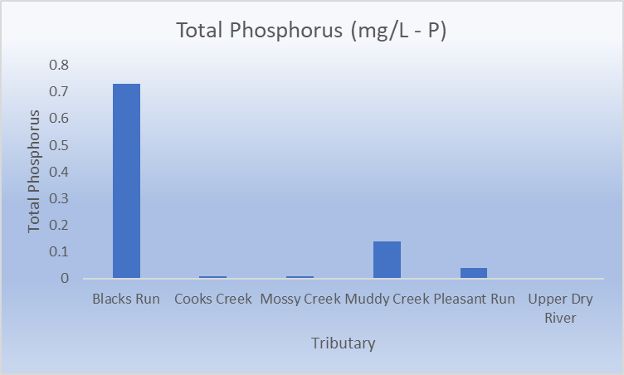

**Figure 12.** Measured total phosphorus present in each Tributary

Cooks Creek, Mossy Creek, and Pleasant Run all have Total Phosphorus (TP) levels slightly above the acceptable threshold of <0.01 mg/L-P (ISAT 320, Dr. Coffman and Kyle Snow, 2024(e)), placing them in borderline health status. These levels of phosphorus pose a serious threat to the health of the aquatic community as it could very easily lead to eutrophication if the phosphorus levels were to increase any further. Blacks Run, with 65% urban land use, exhibits significantly higher TP levels, likely due to urban runoff from the surrounding area. This includes contributions from the nearby Cisco food production factory, as well as other urban processes such as lawn fertilizers and stormwater runoff. Muddy Creek's elevated TP levels are likely due to agricultural practices in the surrounding area, particularly fertilizer use and manure runoff.

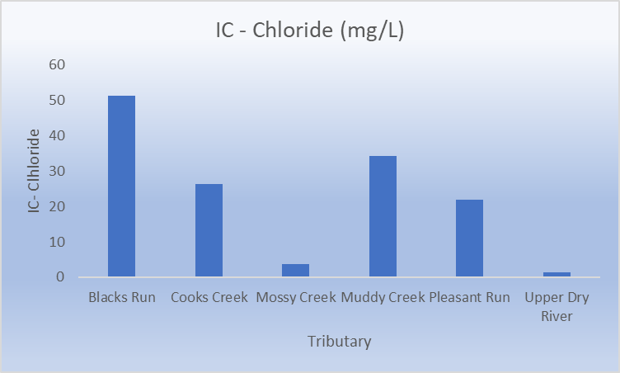

**Figure 13.** Measured amount of IC - Chloride present in each tributary

Chloride is toxic to many organisms, making it a harmful chemical in tributaries. Blacks Run has the highest chloride levels, likely due to a combination of urban runoff, potentially including road salt from ice management, and fertilizer runoff from surrounding agriculture (Kane et al., 2024). Similarly, Cooks Creek, Muddy Creek, and Pleasant Run are likely experiencing high chloride levels from fertilizer runoff used in local agricultural practices.

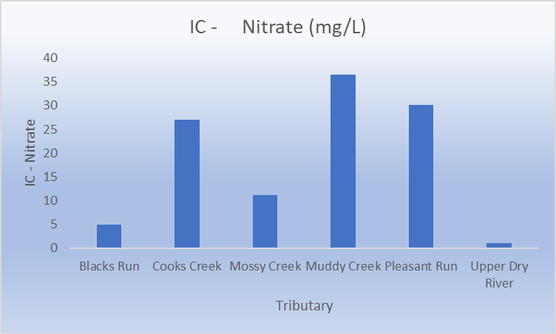

**Figure 14.** Measured Total IC-Nitrates in each tributary

Every tributary measured had nitrate concentrations higher than the threshold for good water health (<0.31 mg/L) (ISAT 320, Dr. Coffman and Kyle Snow, 2024(e)). This is likely due to fertilizer runoff containing nitrates. Additionally, the high coliform and nitrate levels in Muddy Creek and Pleasant Run suggest that animal fecal matter may also be contributing to the elevated nitrate concentrations in these areas. These high nitrate concentrations in tributaries like Muddy Creek, Cooks Creek, and Pleasant Run could potentially lead to eutrophication as nitrogen is a primary contributor to it (Singer, 2016). Mossy Creek’s nitrate concentration is surprisingly low considering much of its surrounding land is agricultural (Table 1). The most reasonable explanation seems to be that the farmers in these areas use fertilizers and pesticides that aren’t nitrogen based or have lower nitrogen content. Another explanation could be that they are using nitrogen based products, but are extremely responsible with their runoff and prevent much of it from polluting the surrounding water.

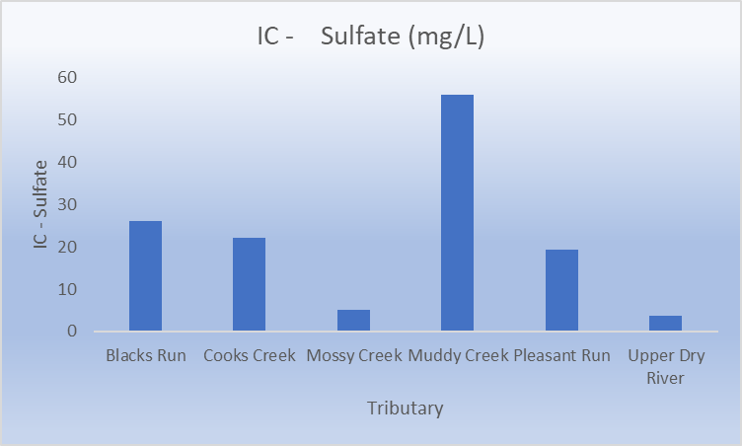

**Figure 15.** Total IC - Sulfate in each tributary

Every tributary has below dangerous levels of sulfate, although some tributaries have significantly higher concentrations of sulfate than others. Sulfates are a nutrient capable of causing eutrophication in high levels (Testing, 2024). Nitrogen and phosphorus are the main contributors to eutrophication, however (Singer, 2016). The greater threat to the health of an aquatic community that sulfate poses is its ability to form into sulfuric acid and acidify the water, which decreases species richness as it can be lethal to many aquatic organisms. Sulfate is a common molecule in agricultural runoff, especially in products like pesticides or fertilizers which would imply that tributaries with greater amounts of surrounding agricultural land would have the highest levels of sulfate. This doesn’t hold true for some of these tributaries though. Muddy Creek has an expectedly higher concentration of sulfate, considering the surrounding land use is 54.76 % agricultural (Table 1), but Mossy Creek, the tributary with the highest amount of surrounding agricultural land, sitting at 71.57 % (Table 1) has the second lowest sulfate concentration. The other tributaries have expected sulfate concentrations for their surrounding agricultural land use percentage. A reasonable explanation for Mossy Creek’s surprisingly low concentration could be that the farmers in the surrounding areas use fertilizers and pesticides with low-sulfur content.

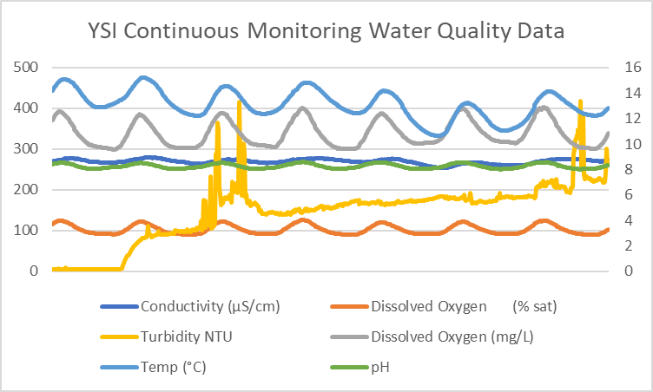

**Figure 16.** YSI Continuous water quality data for days October 23th to October 30th.

Figure 16 displays the daily pattern of a seven day period. The third day had a spike in turbidity which was most likely a storm or rain. The rest of the variables all display the same correlation and trends within each day. There are no major discrepancies among the other parameters. The fluctuation of DO levels for DO (% sat) and DO (mg/L) can be explained by the increase of oxygen in the air due to plants actively photosynthesizing during the day and producing oxygen, some of which then gets dissolved into the stream. The decrease at night occurs due to the lack of photosynthesis taking place. The temperature fluctuations can be explained by the day/night cycle as well since heat from the sun warms the stream during the day and the lack of heat from the sun at night causes the stream to cool. The fluctuations in pH heavily intertwine with photosynthesis as well. Plants and algae in the stream absorb some of the CO2 in the water during the day when photosynthesis is occurring, which reduces carbonic acid in the water, increasing the pH. When respiration levels increase at night, those same plants release CO2 back into the water, increasing carbonic acid levels, and decreasing the pH (Coffman, 2024). Conductivity increases during the day because greater temperature levels in the stream caused by the heat of the sun lead to the ions in the water moving faster. The temperature decrease at night removes a certain amount of energy in the stream, causing the ions to move slower and the conductivity to decrease.

**4.5 Benthic Macroinvertebrate Assessment**

**Table 12.** Metrics from the benthic macroinvertebrate assessment for group S3G1, including six benthic metrics and the Save Our Streams Multimetric Index Score.

| **Group** | **Benthic Metric 1** | **Benthic Metric 2** | **Benthic Metric 3** | **Benthic Metric 4** | **Benthic Metric 5** | **Benthic Metric 6** | **Save Our Streams Multimetric Index Score** |
| --- | --- | --- | --- | --- | --- | --- | --- |
| S3G1 | 22.4 | 11.4 | 5.2 | 4.3 | 48.1 | 52.4 | 5 |

**Table 13.** Summary statistics for all groups, showing averages, maximum, minimum, range, and standard deviation for the Multimetric Index scores.

| **Summary Statistics of all Groups** | **Avg** | **Max** | **Min** | **Range** | **Stdev** |
| --- | --- | --- | --- | --- | --- |
| Multimetric Statistics | 7.5455 | 9 | 5 | 4 | 1.3 |

Our group's Multimetric Index Score of 5 is lower than the class average of 7.55, implying that the area we researched contains less biological diversity. The uneven distribution across the class results demonstrates that stream health varies by site. Our score is on the lower end, showing that certain areas may be under more of an environmental stress than others. In our research, we examined benthic macroinvertebrates and generated many metrics to estimate the biological health of the North River. Table 12 provides the individual scores for each of the six metrics we utilized, as well as the overall Multimetric Index Score. Our score being on the lower end of the range suggests that our sampling area may be facing more stress, like pollution or habitat loss. This could mean fewer species overall and more pollution-tolerant ones, which are usually the first to thrive in degraded environments. When we compared these biological results to the water quality and habitat assessment data, we saw some links. For example, areas with lower dissolved oxygen and higher nutrient levels tend to have more pollution-tolerant species, which would lower the overall health score. Also, factors like habitat degradation, such as sedimentation or the loss of riparian buffers, seem to be tied to lower biological scores. Streams with poor habitat quality often can't support diverse macroinvertebrate populations, leading to lower Multimetric Index Scores. Our group's data, along with the class data, shows the importance of considering both biological and physical factors when looking at stream health. Overall, the data we collected on benthic macroinvertebrates, water quality, and habitat conditions gives a clear picture of the North River's ecological health. While some areas are in good shape, our lower score shows that pollution or habitat loss might be affecting biodiversity in some parts of the river. The connections between the biological, water quality, and habitat data highlight the need for ongoing monitoring and possible efforts to improve the river's health.

**4.6 Fish Community Survey**

| **FISH SPECIES** |
| --- |
| Common shiners |
| Creek chubs |
| Blacknose Daces |
| Fallfish |
| Cutlip Minnow |
| Blunt-nosed Minnows |
| Margined Madtom |
| Mottled Sculpin |
| Rock Bass |
| Green Sunfish |
| Smallmouth Bass |
| Fantail Darters |

A total of 12 fish species were identified at the North River site, resulting in a species richness of 12. This includes common shiners, creek chubs, blacknose daces, fallfish, cutlip minnows, blunt-nosed minnows, margined madtoms, mottled sculpins, rock bass, green sunfish, smallmouth bass, and fantail darters.The diversity of fish species observed is indicative of a healthy ecosystem. Our benthic macroinvertebrate data showed a low Multimetric Index Score of 5, which suggests the area might be under some environmental stress. However, the fish species richness of 12 shows that the North River may still support a variety of fish, some of which might be more tolerant to pollution or environmental stress than the invertebrates we measured. Even though we have a good number of fish species, that doesn't necessarily mean the habitat is in great shape. There could be certain fish species that are more resilient to habitat degradation, which would explain why they are present despite some possible habitat challenges. While looking at water quality and the fish species we found, it might signal some level of tolerance to pollution, especially when the water quality is not the best. Fish species like the smallmouth bass and green sunfish can handle conditions more extreme than other fish like fallfish, which is why we saw smallmouth thriving more in this area of the water than the fallfish. Ultimately, while the fish species richness is a good sign, the low benthic macroinvertebrate score suggests that there could still be some issues with water quality or habitat that need to be addressed. By looking at all these data points together, we get a clearer picture of the river’s health and where improvements might be needed.

**Conclusion**

This study and assessment of the North River watershed provides valuable insights into the interplay of factors influencing water quality and habitat health. While the watershed exhibits diverse land use patterns, including forested, agricultural, and urban areas, the impact of human activities is evident in the observed water quality parameters and biological indicators. The water quality analysis indicated overall high levels of nutrients, especially nitrogen and phosphorus, which can contribute to eutrophication and the growth of harmful algal blooms. Additionally, the presence of E. coli bacteria exceeded the Virginia quality standard limits. These findings showed how it would be beneficial for effective management strategies to be enacted in order to mitigate pollution and protect public health. Habitat assessments revealed variations in stream conditions, with forested areas generally supporting higher quality habitats compared to urban and agricultural areas. The latter two land uses were associated with increased sedimentation, increased runoff, and, as a result, reduced biodiversity.

To improve the ecological health of the North River watershed, a practice that can be implemented would be to establish and maintain riparian buffers along streams. In doing so, the watersheds would be able to support a greater volume of biodiversity because they can filter pollutants and provide habitat for wildlife. Another recommendation could be to work with local communities and policymakers in order to develop and enact effective watershed management plans. While these recommendations may seem ambitious, they are achievable with concerted efforts from various stakeholders. The potential benefits of implementing these measures, such as cleaner water and healthier biodiversity far outweigh the initial costs. However, challenges like limited funding may delay or even stop this progress altogether. Therefore, to ensure the safety of the Sandy Bottom watershed, it is crucial to focus on these recommendations and allot sufficient resources to ensure their successful implementation. Alerting the Harrisonburg and Rockingham County communities to the importance of a healthy aquatic ecosystem in the North River Watershed would be a start. Raising awareness of the current ecological issues within the North River Watershed could lead to the election of local officials that will enact environmentally protective policies that will improve the health of the watershed. While attempting to raise awareness across an entire community can take time, it's certainly doable and, with consistent effort, could inspire lasting change to ensure the protection and sustainability of the watershed.

|  |
| --- |

**References**

ISAT 320 Coffman (2024a). Lab #6: Watersheds. Retrieved from <https://canvas.jmu.edu/courses/2036196/assignments/18873856?module_item_id=40287726>

ISAT 320 Coffman (2024b). Lab #7: Water Quality Sampling and Analysis I, Volume and Flow Measurements, Physical Habitat Assessment. Retrieved from <https://canvas.jmu.edu/courses/2036196/assignments/18873857?module_item_id=40287737>

ISAT 320 Coffman (2024c). Lab #8: North River Assessment II: Macroinvertebrate inventory & Water quality sampling and analysis II. Retrieved from <https://canvas.jmu.edu/courses/2036196/assignments/18873861?module_item_id=40287757>

ISAT 320 Coffman (2024d). Lab #9: North River III: Water Quality Sampling, Stream Discharge, Habitat Assessment, and Fish Assemblage. Retrieved from <https://canvas.jmu.edu/courses/2036196/assignments/18873864?module_item_id=40287767>

ISAT 320 Coffman (2024e). Lab #10: tributary sampling. Retrieved from <https://canvas.jmu.edu/courses/2036196/assignments/18873863?module_item_id=41120345>

Jennifer Coffman. October 24, 2024. *Water! There’s Still More to Know . . .* <https://canvas.jmu.edu/courses/2036196/assignments/18873892?module_item_id=40287746>.

Kane, D.D., Manning, N.F., Jacquemin, S.J. et al. A Tale of Two Tributaries: Source Delineation of Chloride in a Distressed Watershed (Grand Lake St. Marys, Ohio). Water Air Soil Pollut 235, 658 (2024). <https://doi.org/10.1007/s11270-024-07455-0>. Accessed 12/6/24.

Singer, Fred D. 2016. *Ecology in Action*. Cambridge University Press, Cambridge, United Kingdom.

Testing, O. W. 2024, December 3, 2024. *The role of sulfate in Water Quality and Health.* Olympian Water Testing, LLC. Olympian Water Testing. <https://olympianwatertesting.com/aquawiki/sulfate/the-role-of-sulfate-in-water-quality-and-health/#elementor-toc__heading-anchor-5>. December 7, 2024.

**Testing, O. W. (2024, December 3). *The role of sulfate in Water Quality and Health - Olympian Water Testing, LLC*. Olympian Water Testing. https://olympianwatertesting.com/aquawiki/sulfate/the-role-of-sulfate-in-water-quality-and-health/#elementor-toc__heading-anchor-5**

**he Role of Sulfate in Water Quality and Heal**